ASSIGNMENT # 3

SUBMITTED TO :

SIR SOHAIL IQBAL

DATE: 22ND MAY, 2018

**SUBMITTED BY:**

**ASFA JAMIL**

**REG # 134637**

**BESE 6-B**

**Link to repository:**

https://github.com/asfa164/fmAssignment.git

**QUESTION NO.1:**

**2 JOBBERS ARE ADDED.**

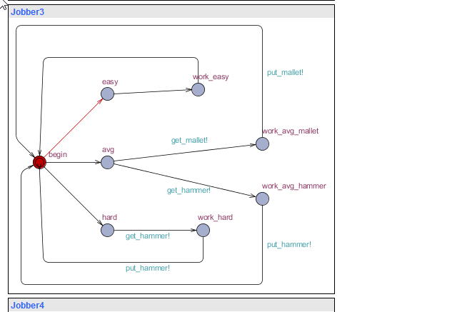

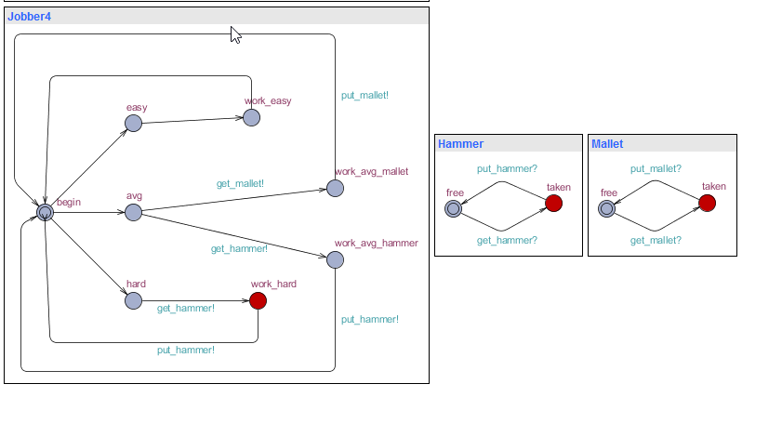

**SYSTEM DECLARATION:**

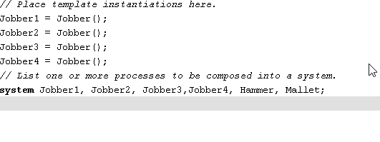

**QUERIES:**



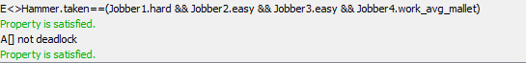

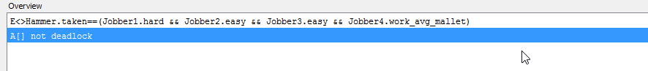

**Question 2**

**1 RESOURCE**

**4 ROADS.**

**4 USERS.**

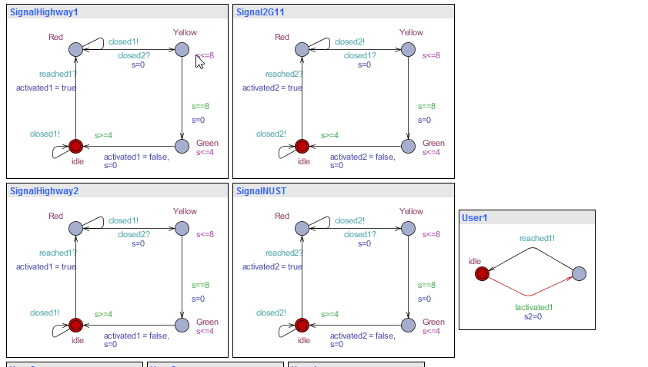

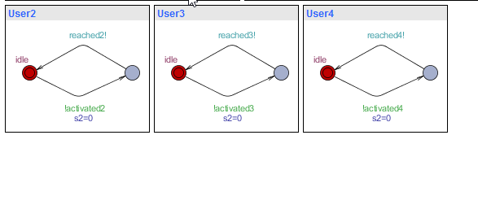

**QUERIES**

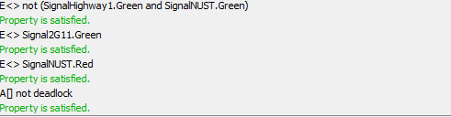

**QUESTION # 3:**

**POSTS AND COMMENTS:**

